Deep Learning

**Practical: 10**

|  |  |
| --- | --- |
| Name of the student | Saurabh Agarwal |
| Roll No. | J001 |
| Class | B.Tech Data Science 3rd Year |

**Transfer learning:**

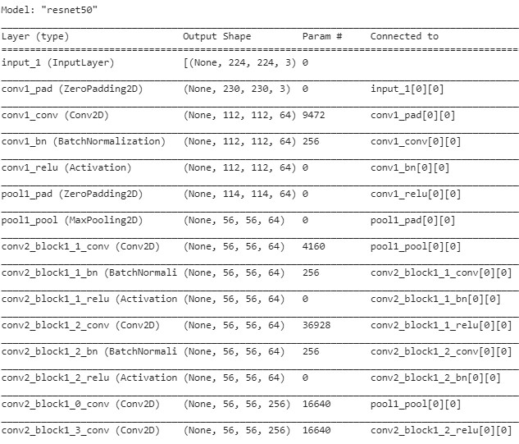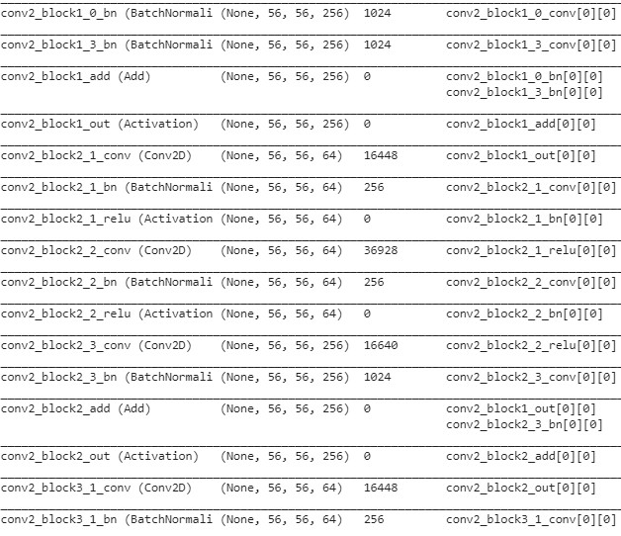

**Bottleneck feature:**

loss: 1.3363e-05 - accuracy: 1.0000 - val_loss: 4.7445 - val_accuracy:

0.4667

**Code:**

<https://colab.research.google.com/drive/17I2Ue7sUvz7DWEmZp57BBX8c8_t6Avw0> <https://colab.research.google.com/drive/1GQ7Qj9TG7rOS5aw6fI2PM5MNFonTMCX7> <https://colab.research.google.com/drive/1ac7jfrfE9K-uLgSRm73NKeATRRfeYaBL>